Packet Tracer - Configuring a Floating Static Route

1. Topology

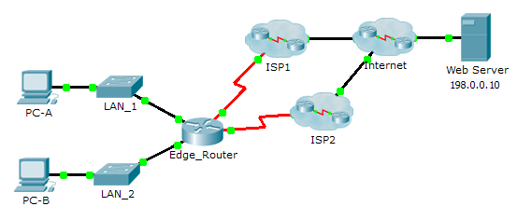

1. Objectives

Part 1: Configure a Floating Static Route

Part 2: Test Failover to the Backup Route

1. Background

In this activity, you will configure a floating static route which is used as a backup route. This route has a manually configured administrative distance greater than that of the primary route and, therefore, would not be in the routing table until the primary route fails. You will test failover to the backup route, and then restore connectivity to the primary route.

1. Configuring a Floating Static Route
   1. Configure a directly attached static default route.
      1. Configure a directly attached static default route from **Edge_Router** to the Internet. The primary default route should be through **ISP1**.
      2. Display the contents of the routing table. Verify that the default route is visible in the routing table.
      3. What command is used to trace a path from a PC to a destination? ______________________________

From **PC-A**, trace the route to the **Web Server**. The route should start at the default gateway 192.168.10.1 and go through the 10.10.10.1 address. If not, check your static default route configuration.

* 1. Configure a floating static route.
     1. What is the administrative distance of a static route? __________________________________________
     2. Configure a directly attached floating static default route with an administrative distance of 5. The route should point to **ISP2**.
     3. View the running configuration and verify that the floating static default route is there, as well as the static default route.
     4. Display the contents of the routing table. Is the floating static route visible in the routing table? Why or why not?

____________________________________________________________________________________

____________________________________________________________________________________

____________________________________________________________________________________

1. Test Failover to the Backup Route
   * 1. On **Edge_Router**, administratively disable the exit interface of the primary route.
     2. Verify that the backup route is now in the routing table.
     3. Trace the route from **PC-A** to the **Web Server**.

Did the backup route work? If not, wait a few more seconds for convergence and then re-test. If the backup route is still not working, investigate your floating static route configuration.

* + 1. Restore connectivity to the primary route.
    2. Trace the route from **PC-A** to the **Web Server** to verify that the primary route is restored.

1. Suggested Scoring Rubric

|  |  |  |  |
| --- | --- | --- | --- |
| Activity Section | Question Location | Possible Points | Earned Points |
| Part 1: Configuring a Floating Static Route | Step 1c | 2 |  |
| Step 2a | 3 |  |
| Step 2d | 5 |  |
| **Part 1 Total** | | **10** |  |
| **Packet Tracer Score** | | **90** |  |
| **Total Score** | | **100** |  |